**An Android Dev Project Report On**

**GROCERY LIST APPLICATION USING KOTLIN**

**IN ANDROID STUDIO**

**SUBMITTED BY:**

**Siddhesh Avinash Dhinge**

**UNDER**

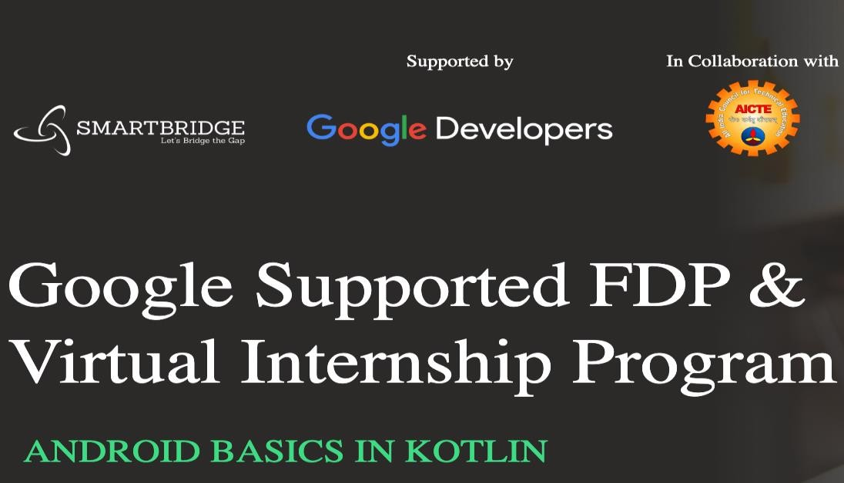

Virtual Internship - Android Application

Development Using Kotlin

# INDEX

**CHAPTER 1: Introduction**

* 1. Abstract
  2. Objective
  3. Problem Targeted
  4. Problem’s Primary Goals
  5. Introduction

# CHAPTER 2: Background & Diagrams

* 1. Background
  2. Context Diagram
  3. Flow Chart

# CHAPTER 3: Technical Requirements

* 1. Development Software Requirement
  2. Development Hardware Requirement
  3. User Software Requirement
  4. User Hardware Requirement

# CHAPTER 4: Implementation and Designing

* 1. MVVM
  2. ROOM DATABASE
  3. RECYCLERVIEW
  4. COROUTINES

# CHAPTER 5: Outcome and Conclusion

* 1. Results
  2. Advantages and Disadvantages
  3. Conclusion
  4. Future Scope

# CHAPTER 6: URLs, Account IDs, and Acknowledgements

* 1. URLs & Account Ids
  2. Acknowledgements

# CHAPTER 1: Introduction

* 1. **ABSTRACT**

Shopping is one of the activities that some people consider part of their life, while others do not even think of it. This comparison makes us discover people's problems with shopping. People have shopping problems such as limited time, expats in foreign countries without cars, a transportation issue, people consider physical shopping as a waste of time, health issues, long- distance to market. And the difficulty in obtaining some items.

As the problems mentioned above, we have explored our idea, which is related to personal shopping. Therefore, we have built an application that combines different market shops, i.e. (Malls, supermarkets, and pharmacies).

This personal grocery shopping is an innovative app that allows the customers to get all their needs and suggest items based on previous history. Then deliver items to their doorstep and can facilitate online shopping procedure where customers can browse unlimited products all at one time. This work supports people in exploiting their time to be safer and more accessible than wasting it physically.

Moreover, people can order the product from home instead of going around for long distances for shopping. In addition, this app could help people who are facing health problems and unable to buy something physically to avoid future problems.

Finally, some people do not have transportation methods for shopping, and they should keep pace with the evolution.

# OBJECTIVE

The main aim of this project is to list the items so that whenever users go to grocery stores, users will not be able to forget their items and this grocery application helps the users to tackle their day-to-day chaos more effortlessly.

# PROBLEM TARGETED

It’s not easy for the users to remember every item in this hectic lifestyle, they frequently can’t recall their required necessity, so we decided to build an app to store the items in the database for their future use. After buying the items users can delete the added items in the database.

# PROBLEM’S PRIMARY GOALS

The goal of this project is to make an app that stores the user items in a cart and can modify and delete the added item in the list. To develop a reliable system, I have some specific goals such as:

* Develop a system such that users can add item details like product name, product Quantity, and Product Price.
* Develop a database room that is used to store the user data which already been added by the user in the cart and the user can also remove the previously added item in the cart.
* Develop a good UI design that user friendly to the user.
* Develop a good UI that is supported for all android devices.

# INTRODUCTION

Many times, when we go to do shopping, we forget to purchase the items we initially went to purchase, this leads to us going to market again and wastage of time and energy.

To resolve this issue, we are going to build a grocery application in android using Android Studio. Many times, we forget to purchase things that we want to buy, after all, we can’t remember all the items, so with the help of this app, you can note down your grocery items that you are going to purchase, by doing this you can’t forget any items that you want to purchase.

In this project, we are using (MVVM) for architectural patterns, Room for database, Recycler View and Coroutines to display the list of items.

**CHAPTER 2: Background & Diagrams**

* 1. **BACKGROUND**

The grocery cart application project will help the user or admin to store the list of items in proper sequence. User/Admin can add and remove the items in the list according to his/her will.

• UI DESIGN IN THE ANDROID PLATFORM

• ANDROID APPLICATION DEVELOPMENT

• DATABASE CONNECTION TO STORE USER DATA

# CONTEXT DIAGRAM

**Enter the item names to Grocery DB**

**Add the Items to Grocery DB**

**Delete the Items from the Grocery DB**

# FLOW CHART

**CHAPTER 3: Technical Requirements**

# Development Software Requirement

The Software Package is developed using Kotlin and Android Studio, basic SQL commands are used to store the database.

Operating System: Windows 8 Software: Kotlin and Java

Device: Redmi Note 5 Pro for development

# Development Hardware Requirement

RAM: 8 GB RAM

ROM: 20 GB ROM

# User Software Requirement

Operating System: Android version 7 or greater.

# User Hardware Requirement

RAM: 512 MB

ROM: 1 GB

**CHAPTER 4: Implementation and Designing**

In this project, we are using MVVM (Model View ViewModel) for architectural patterns, Room for database, Coroutines and Recycler View to display the list of items.

# MVVM (Model View ViewModel)

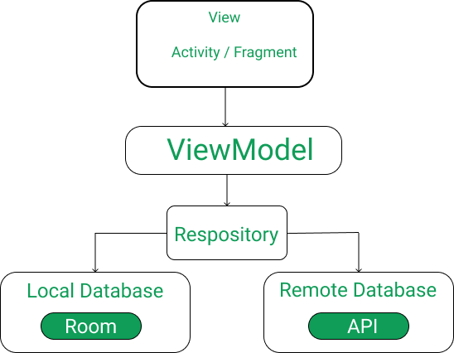

MVVM architecture in android is used to give structure to the project’s code and understand code easily. MVVM is an architectural design pattern in android. MVVM treat Activity classes and XML files as View. This design pattern separates UI from its logic. Here is an image to quickly understand MVVM.

**ROOM Database**

Room persistence library is a database management library, and it is used to store the data of apps like grocery item name, grocery item quantity, and grocery item price. Room is a cover layer on SQLite which helps to perform the operation on the database easily.

**Recycler View**

Recycler View is a container, and it is used to display the collection of data in a large amount of data set that can be scrolled very effectively by maintaining a limited number of views.

**Coroutines**

Coroutines are a lightweight thread, we use coroutines to perform an operation on other threads, by this our main thread doesn’t block and our app doesn’t crash.

# CHAPTER 5: Outcome and Conclusion

# 5.1 Results

# Advantages and Disadvantages

* This app is useful to remind the user about what is needed to buy from the market
* App also calculates the amount needed to buy the items needed from market this makes managing bills easier.
* User can get a clear idea about what the cumulative amount will be.
* User does need to enter all the items one by one.
* This makes entering large lists of items harder and lengthy.
* User still needs to open the app to view the items needed.

# Conclusion

This grocery application will help to store the list of data items include name of item, price and quantity required. Admins store his/her data in the list, the grocery application very helpful to users.

# 5.4 Future Scope:

This application helps to store the list of items by Admin. In Future we can also add scheduled addition of items according to requirement of user.

The Features are:

* + - Add User Panel
    - Add Admin Panel
    - Provide Login Authentication
    - Add Image to user Product and Rating

**CHAPTER 6: URLs, GitHub URL, Account IDs, and Acknowledgements**

**6.1 URLs & Account Ids**

* + - * **GitHub URL**

[**https://github.com/smartinternz02/SPSGP-101603-Virtual-Internship---Android-Application-Development-Using-Kotlin**](https://github.com/smartinternz02/SPSGP-101603-Virtual-Internship---Android-Application-Development-Using-Kotlin)

# Demo Link:

# <https://youtu.be/0LAbl8I2qUo>

* + - * **Smart Internz Profile Link:**

[**https://smartinternz.com/student-profile/feed/U0IyMDIyMDI0NzI2OQ==**](https://smartinternz.com/student-profile/feed/U0IyMDIyMDI0NzI2OQ==)

**6.2 Acknowledgements**

I have taken many efforts in this project. However, it would not have been possible without the kind support and help of many individuals and organizations. I would like to extend my sincere thanks to all of them.

I am highly indebted to SMARTINTERNZ (Experiential Learning & Remote Externship Platform to bring academia & industry very close for a common goal of talent creation) for their guidance and constant supervision as well as for providing necessary information regarding the project & also for their support in completing the project. I would like to express my gratitude towards member of (SmartInternz) for their kind co-operation and encouragement which help me in completion of this project.

I would like to express my special gratitude and thanks to industry persons for giving me such attention and time.

My thanks and appreciations also go to people who have willingly helped me out with their abilities.